HOSPITAL FINDER

A PROJECT REPORT

Submitted by,

Mr. Maheshwar Reddy - 20211CBD0059
Mr. Vadde Vinod-20211CBD0018
Mr. Mahammad Thouheed-20211CBD0051
Mr. Mahammad Ajar-20211CBD0010

Under the guidance of,
DR. SRINIVASAN T R
Professor
School of Computer Science and Engineering,
Presidency University, Bengaluru

in partial fulfillment for the award of the degree of
BACHELOR OF TECHNOLOGY

IN

COMPUTER SCIENCE AND ENGINEERING

At



PRESIDENCY UNIVERSITY
BENGALURU
DECEMBER 2024

PRESIDENCY UNIVERSITY

SCHOOL OF COMPUTER SCIENCE AND ENGINEERING

CERTIFICATE

This is to certify that the Project report “ Hospital Finder App ” being submitted by “Maheswar Reddy , Vadde Vinod , Mahammad Thouheed , Mahammad Ajar “ bearing roll numbers “20211CBD0059, 20211CBD0018, 20211CBD0051, 20211CBD0010” in partial fulfillment of the requirement for the award of the degree of Bachelor of Technology in Computer Science and Engineering is a bonafide work carried out under my supervision.

DR. SRINIVASAN T R  Professor  School of CSE  Presidency University | DR. PRAVINTHRAJA  Professor & HoD  School of CSE  Presidency University

Dr. L. SHAKKEERA  Associate Dean  School of CSE  Presidency University | Dr. MYDHILI NAIR  Associate Dean  School of CSE  Presidency University | Dr. SAMEERUDDIN KHAN  Pro-VC School of Engineering  Dean -School of CSE&IS  Presidency University

PRESIDENCY UNIVERSITY

SCHOOL OF COMPUTER SCIENCE AND ENGINEERING

DECLARATION

We hereby declare that the work, which is being presented in the project report entitled Hospital Finder App in partial fulfillment for the award of Degree of Bachelor of Technology in Computer Science and Engineering, is a record of our own investigations carried under the guidance Ms. Ayesha Taranum, Assistant Professor, School of Computer Science Engineering, Presidency University, Bengaluru.

We have not submitted the matter presented in this report anywhere for the award of any other Degree.

Name | Roll No | Signature
Maheswar Reddy | 20211CBD0059
Vadde Vinod | 20211CBD0018
Mahammad Thouheed | 20211CBD0051
Mahammad Ajar | 20211CBD0010

ABSTRACT
The Hospital Finder app is an innovative solution to address the challenges of accessing appropriate healthcare services during emergencies. Designed with a focus on reliability and efficiency, the app provides users with real-time information on hospital services, including bed availability, specialist doctors, emergency care facilities, and user reviews. This ensures that patients can make informed decisions during critical situations, potentially saving lives by reducing delays in receiving medical attention.
The application’s backend architecture is developed using Java for robust data processing and MySQL for secure and efficient data storage. This allows the app to handle large volumes of hospital information and ensure real-time updates. The frontend incorporates a user-friendly interface, designed with simplicity in mind, to provide a seamless experience for users of all ages and technical expertise. Key features include dynamic filtering options, where users can search for hospitals based on specific medical needs such as required treatments, specialties, or critical care units.
To ensure a reliable experience, the app integrates features that prioritize data accuracy, user privacy, and security. By connecting patients with the right healthcare facilities, the app not only enhances decision-making capabilities but also optimizes hospital resource utilization by reducing overcrowding and directing patients to appropriate facilities.
This project envisions a future where advanced functionalities, such as integration with emergency response systems and predictive analytics for hospital traffic, can further enhance the app’s utility. By bridging the gap between patients and healthcare providers, the Hospital Finder app aims to revolutionize the way medical emergencies are managed, ensuring timely access to life-saving care.

ACKNOWLEDGEMENTS

First of all, we indebted to the GOD ALMIGHTY for giving me an opportunity to excel in our efforts to complete this project on time.
We express our sincere thanks to our respected dean Dr. Md. Sameeruddin Khan, Pro-VC, School of Engineering and Dean, School of Computer Science Engineering & Information Science, Presidency University for getting us permission to undergo the project.
We express our heartfelt gratitude to our beloved Associate Deans Dr. Shakkeera L and Dr. Mydhili Nair, School of Computer Science Engineering, Presidency University, and “Dr PRAVINTHRAJA” Head of the Department, School of Computer Science Engineering, Presidency University, for rendering timely help in completing this project successfully.
We are greatly indebted to our guide DR. SRINIVASAN T R, Professor and Reviewer Mr. RAJAN T, Assistant Professor, School of Computer Science and Engineering, Presidency University for his inspirational guidance, and valuable suggestions and for providing us a chance to express our technical capabilities in every respect for the completion of the project work.
We would like to convey our gratitude and heartfelt thanks to the PIP2001 Capstone Project Coordinators Dr. Sampath A K, Dr. Abdul Khadar A and Mr. Md Ziaur Rahman and Git hub coordinator Mr. Muthuraju V.
We thank our family and friends for the strong support and inspiration they have provided us in bringing out this project.

Maheswar Reddy
Vadde Vinod
Mahammad Thouheed
Mahammad Ajar.

LIST OF TABLES

Sl. No. | Table Name | Table Caption | Page No.
1 | Table 1 | TimeLine Of the Project | 15

LIST OF FIGURES

Sl. No. | Figure Name | Caption | Page No.
1  2  3  4  5 | Figure 1  Figure 2  Figure 3  Figure 4  Figure 5 | Architecture of the hospital Finder  System Design & Implementation  Home page  Hospital List page  SDG of Hospital Finder | 8  13  29  30  31

CONTENTS

CHAPTER NO. | TITLE | PAGE NO.
 | ABSTRACT | 4
 | ACKNOWLEDGMENT | 5
1 | INTRODUCTION  - THE IMPORTANCE  - MODREN USAGE  - BENEFITS AND CHALLENGES | 1-3
2 | LITERATURE REVIEW | 4-5
3 | RESEARCH GAPS OF EXISTING METHODS | 6-7
4 | PRAPOSED METHODOLOGY | 8-10
5 | OBJECTIVES | 11-12
6 | SYSTEM DESIGN & IMPLEMENTATION | 13-14
7 | TIMELINE FOR EXECUTION OF PROJECT | 15
8 | OUTCOMES | 16
9 | RESULTS AND DISCUSSIONS | 17-20
10 | CONCLUSION | 21
 | REFERENCES | 22

CHAPTER-1
INTRODUCTION
The Health Finder app addresses the critical need for timely medical assistance by simplifying the search process during emergencies. By providing essential details about nearby hospitals, including available services, medications, and specialist care, the app empowers users to make quick, informed decisions when every second counts. It offers live updates on factors like bed availability, emergency room capacity, and specialist availability, ensuring that users are directed to a hospital that can meet their immediate needs. The app incorporates smart filtering to match users with facilities that align with specific medical requirements, such as blood type availability or specialized care units. This level of precision greatly enhances the chances of receiving the right treatment in time. Through an intuitive user interface, the app aims to be accessible to all, ensuring that even in stressful situations, navigating the app remains simple and efficient. Ultimately, Health Finder seeks to bridge the gap between individuals in need and accessible healthcare services, reducing delays and ensuring that help is always just a tap away.

  - The Importance of Hospital Finder Application in Society

The Hospital Finder application plays a transformative role in society by enhancing access to timely medical care during emergencies. By providing real-time information on hospital availability, specialist services, and other critical resources, it reduces delays in receiving treatment, potentially saving lives. The app empowers individuals to make informed decisions by offering detailed hospital profiles tailored to their specific needs, ensuring better healthcare outcomes.
Beyond individual benefits, the app optimizes the utilization of healthcare resources by directing patients to underutilized facilities, reducing overcrowding at popular hospitals. This promotes a more balanced and efficient healthcare system. Its role in emergency preparedness, especially during disasters or public health crises, ensures faster response times and better coordination among healthcare providers. Additionally, the app’s user-friendly design supports vulnerable populations, such as the elderly or those unfamiliar with healthcare systems, ensuring equitable access to care.

The application also has the potential to generate valuable insights into healthcare trends, aiding policymakers in addressing systemic gaps and planning future interventions. By integrating with emergency services and encouraging proactive health management, the Hospital Finder app contributes significantly to building a healthier and more resilient society.
  - Modern usage of the Application in Emergency Situations
The Hospital Finder app leverages modern technology to assist in swift and informed decision-making during emergencies. With real-time data on hospital services, bed availability, and specialists, users can quickly identify the most suitable facilities for their needs. Features like dynamic filtering and AI-driven recommendations streamline the process by analyzing user inputs and suggesting optimal options based on proximity and resource availability, ensuring timely care.
Integration with navigation systems, ambulance services, and emergency hotlines enhances its functionality, while crowdsourced feedback adds transparency about hospital performance. Offline access and wearable device integration further extend its utility, making the app reliable even in remote or low-connectivity areas. By reducing delays and simplifying emergency responses, the app proves invaluable in managing urgent healthcare scenarios efficiently.

1.3. Benefits and Challenges of Hospital Finder Application
The Hospital Finder application offers several key benefits, primarily improving access to healthcare during emergencies. It provides real-time information on nearby hospitals, helping users make quick and informed decisions based on available resources, specialties, and bed availability. This can significantly reduce delays in emergency care, improving patient outcomes. Additionally, the app’s ability to filter hospitals by specific needs, such as trauma care or ICU services, ensures that users are directed to the most suitable facility for their condition. Integration with navigation and emergency services further enhances its usability and effectiveness in critical situations.

However, the Hospital Finder app also faces challenges, particularly in terms of data accuracy and coverage. Real-time data can sometimes be unreliable due to hospital reporting delays or technical issues, leading to outdated or incomplete information. Another challenge is ensuring broad accessibility, as areas with poor internet connectivity or low smartphone penetration may not fully benefit from the app’s features. Additionally, maintaining user privacy and securing sensitive health data are ongoing concerns, requiring robust security measures to prevent data breaches. Despite these challenges, the app offers a valuable tool for improving healthcare access in emergencies, with room for further development and refinement.

CHAPTER-2
LITERATURE SURVEY

Amit Kumar Emergency Health Care Services in India: A Strategic Approach.
International Journal for Multidisciplinary Research, Integrates pre-hospital and facility-based care using telemedicine and emergency response technologies.
Proposes a unified emergency surveillance system that integrates pre-hospital and facility-based care using telemedicine and emergency response technologies.
Fragmentation of healthcare services, lack of trained personnel, and insufficient infrastructure pose significant barriers to implementation. Faces barriers like service fragmentation, inadequate personnel, and insufficient infrastructure.

Kartik Mishra Mobile Health Apps and the Future of Emergency Medical Care in India.
Journal of Mobile Technology in Healthcare, Employs AI-enabled mobile health apps to predict hospital crowding and recommend hospitals.
Utilizes mobile health apps with embedded AI algorithms to predict hospital crowding and suggest the best hospitals based on patient flow and emergency severity.
Data reliability is an issue due to the fragmented nature of the Indian healthcare system and the limited adoption of digital health technologies.

Naveen Sharma Emergency Response Systems in India: Leveraging Mobile Applications for Faster Access to Healthcare. Journal of Emergency Medical Services, Connects mobile apps to a centralized emergency network for ambulance dispatch and hospital guidance.
Mobile apps connected to a centralized emergency response network to dispatch ambulances and guide users to the nearest hospitals.
Limited access in areas without strong mobile networks, and the system is reliant on real-time ambulance availability, which can cause delays during high-demand periods.

Shruti Desai Optimization of Hospital Selection Algorithms for Emergency Medical Care in Urban India. Journal of Applied Algorithms and Computation, Develops algorithms to prioritize hospitals based on distance, specialties, and crowding.
Develops algorithms that prioritize hospitals based on distance, specialty, and crowding factors, providing users with the optimal choice in emergency scenarios.
Real-time data accuracy is challenging in urban environments due to traffic congestion and frequent hospital overcrowding.

Suresh Patil Emergency Medical Care System Using GPS and Mobile Applications in Rural India. Journal of Healthcare Informatics Research, Implements a GPS-enabled emergency response system integrated with mobile apps and local healthcare centers.
Implements a GPS-enabled emergency response system for rural India, integrating mobile apps with local healthcare centers for faster emergency responses.
Lack of reliable internet connectivity in rural areas hinders the app’s functionality, and local healthcare centers often face resource shortages.

Anjali Bhatt The Role of Mobile Health Applications in Streamlining Emergency Medical Services in India. Journal of Health Technology, Connects mobile health apps with a central dispatch system to locate nearby hospitals and ambulances.
Mobile health applications connected with a central dispatch system to alert users about nearby hospitals and ambulances in emergencies.
Heavy reliance on mobile connectivity and challenges in synchronizing real-time data between private and government hospitals.

Zhao Jinxian et al , Subway Shield Construction Evaluation. Urban Infrastructure Journal,
Proposes a knowledge management system (KMS) to enhance medical decision-making through shared expertise. Requires a high degree of collaboration across medical teams, which can be difficult to achieve in practice. Collaboration across medical teams is challenging in practice.

Lin et al., Knowledge Management in Healthcare Systems. Knowledge Systems Journal
Uses a fuzzy theory-based model combined with the WSR methodology to evaluate the effectiveness of infrastructure projects like emergency hospitals.
The complexity of the model makes it difficult to apply quickly in real-time emergency situations.

CHAPTER-3
RESEARCH GAPS OF EXISTING METHODS

Data Accuracy and Real-Time Updates

Existing hospital finder applications often struggle with providing accurate, real-time data. Hospital information such as bed availability, medical services, and specialist availability may not always be up-to-date, leading to unreliable recommendations. There is a need for more dynamic systems that integrate with hospital databases for real-time updates, ensuring users have the most current information when making critical decisions.

Limited Coverage in Rural and Remote Areas

Many current applications are limited in their coverage, especially in rural or underserved regions. Hospitals in these areas may not be included in the database, or the data may be outdated. Enhancing the geographic scope and ensuring accurate data from remote areas is a significant research gap that needs to be addressed to ensure equal access to emergency healthcare.

Integration with Emergency Services

Most hospital finder apps do not effectively integrate with emergency services like ambulances, which is crucial in time-sensitive situations. Future research could explore the integration of hospital finder apps with emergency medical services to ensure seamless coordination and faster response times, potentially reducing the time taken to transfer patients to appropriate facilities.

Personalization and AI Integration

While some hospital finder applications use basic filtering to suggest nearby hospitals, they lack the advanced personalization and artificial intelligence (AI) capabilities that can enhance user experience. Research into AI-powered recommendation systems that consider individual patient needs (e.g., medical history, condition severity, real-time health data) could significantly improve decision-making.

User Experience and Accessibility

The user interface of many existing hospital finder applications may not be optimized for all user demographics, particularly for elderly users or those unfamiliar with technology. Improving accessibility and ensuring that the interface is intuitive and easy to navigate during emergencies is another critical gap that warrants further exploration.

Data Privacy and Security

With the increasing use of personal health data in hospital finder applications, ensuring robust data privacy and security is a significant concern. Research into advanced encryption techniques and secure data-sharing protocols is essential to mitigate privacy risks and ensure that users' personal and medical information remains protected.

Interoperability with Healthcare Systems

Current hospital finder applications often operate in isolation, without integration with national or regional healthcare systems. Exploring interoperability between hospital finder apps and electronic health records (EHR) or health information exchanges (HIE) could improve the quality of recommendations and streamline emergency care.

CHAPTER-4
PROPOSED METHODOLOGY
Design Procedure:

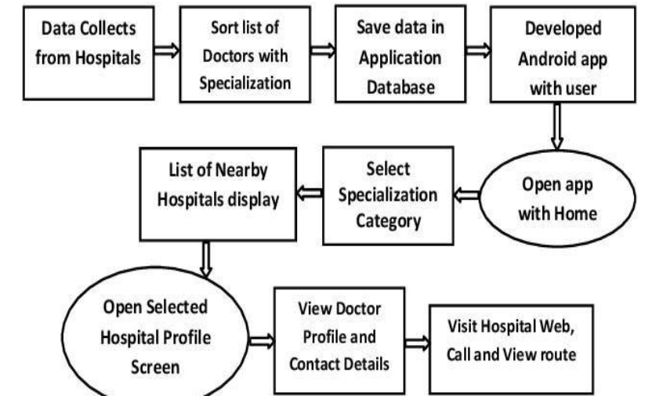Fig 4.1:Architecture of Hospital Finder Application

4.1. Steps for Design Procedure

4.1.1. User Interface (UI) Layer

Components: This includes all the elements that users interact with, such as search bars, maps, hospital listings, and user profiles.

Technologies:

Web: HTML, CSS, JavaScript (with frameworks like React or Angular).

Mobile: Swift for iOS, Kotlin/Java for Android.

Details: The UI layer is responsible for rendering data in a user-friendly manner and capturing user inputs.

4.1.2. Application Layer

Components: This layer contains the core business logic of the application.

Technologies:

Backend Frameworks: Node.js (JavaScript), Django (Python), Spring Boot (Java).

Details: It processes user requests, applies business rules, and interacts with the database and external APIs. For example, when a user searches for hospitals, this layer handles the search logic and filters results based on criteria like location and specialty.

4.1.3. Database Layer

Components: This layer manages data storage and retrieval.

Technologies:

SQL Databases: MySQL, PostgreSQL.

NoSQL Databases: MongoDB, Firebase.

Details: It stores information about hospitals, user profiles, reviews, and other relevant data. The database schema is designed to efficiently handle queries and updates.

4.1.4. API Layer

Components: This layer facilitates communication between the application and external services.

Technologies:

API Protocols: RESTful APIs, GraphQL.

Details: It handles requests to and from third-party services. For instance, it might call the Google Maps API to get geolocation data or a weather API to provide local weather information.

4.1.5. External Services

Components: These are third-party services that provide additional functionalities.

Examples:

Google Maps API: For geolocation and mapping.

Twilio: For sending SMS notifications.

Details: These services are integrated into the application to enhance its capabilities. For example, Google Maps API can be used to show hospital locations on a map.

4.1.6. Security Layer

Components: This layer ensures the application is secure from various threats.

Technologies:

Authentication: OAuth, JWT (JSON Web Tokens).

Communication Security: HTTPS, SSL/TLS.

Details: It protects user data and ensures secure communication between the client and server. This includes user authentication, data encryption, and secure API calls.

4.1.7. Deployment Layer

Components: This layer involves the infrastructure where the application is hosted.

Technologies:

Cloud Services: AWS (Amazon Web Services), Azure, Google Cloud Platform.

Details: It ensures the application is scalable, reliable, and available. This includes setting up servers, databases, and load balancers.

Example Workflow:

User Search: A user enters a search query for hospitals in a specific area.

Request Handling: The application layer processes the search request.

Data Fetching: The API layer retrieves data from the database and external services like Google Maps.

Response Compilation: The application layer compiles the data and prepares it for the UI.

Display: The UI layer displays the search results to the user, showing hospital locations on a map and relevant details.

CHAPTER-5
OBJECTIVE

Proposed Objectives for Hospital Finder

- Real-time Hospital Information:
The app will use GPS to identify the user's current location and display nearby hospitals in real-time. It will provide key details like hospital name, contact info, address, and current occupancy (if available), allowing users to make quick decisions in case of emergencies or planned visits. Additionally, users will be able to see the operating hours and any real-time updates about hospital status, such as whether emergency services are available or full. This will enable users to make informed choices based on the most current hospital conditions, especially during critical moments.

- Filter by Medical Facilities & Specialties:
The app will allow users to customize their search based on specific healthcare needs. For example, if a user requires a hospital with a maternity ward, a cardiac unit, or a specific specialty like pediatrics or orthopedics, they can filter their options accordingly. This helps users find the right healthcare facility suited to their medical condition. Moreover, users can refine their search to find hospitals with specialized equipment or treatments, such as MRI or cancer care centers, to match their exact healthcare requirements. The ability to customize search criteria ensures users can easily find the most appropriate medical services.

- User-friendly Interface:
The app’s design will be simple and intuitive, ensuring users can easily navigate through the features. It will focus on clarity and accessibility, with large, easy-to-read fonts, simple icons, and quick access to important features like search, hospital details, and directions. The interface will also include visual indicators, such as color-coded icons for different hospital specialties, helping users quickly identify hospitals that meet their needs. Additionally, the app will offer easy-to-understand navigation menus and quick actions for emergency situations, providing users with a stress-free experience.

- Data Privacy & Security:
To protect sensitive user information, the app will implement robust security measures like data encryption, secure login protocols (e.g., two-factor authentication), and comply with data protection laws (like GDPR or HIPAA). Personal and medical data will be stored securely, and users will have control over their data, ensuring privacy is maintained at all times. The app will also employ regular security audits and updates to address emerging threats and vulnerabilities, ensuring continuous protection of user information. By implementing these practices, the app ensures users' trust and safety, particularly when handling sensitive medical or location data.
CHAPTER-6
SYSTEM DESIGN & IMPLEMENTATION


Fig 6.1: Architecture of Hospital Finder Application

The Proposed method consists of the following steps:

This healthcare application is designed using a three-tier architecture, consisting of a presentation layer (user interface), application layer (business logic), and data layer (centralized database). The system comprises key modules, including Home, Hospital Search.
In the high-level design (HLD), the focus is on the architecture and core functionalities, ensuring smooth navigation between features, secure data handling, and scalability. The low-level design (LLD) dives into detailed implementation for each module, such as input validation, workflows, data storage, and error handling.

1. Data Collection:
- Collect data from hospitals, including doctor details, specializations, and other relevant information.
2.Data Sorting:
- Sort the list of doctors based on their specialization to organize the database efficiently.
3.Database Storage:
- Save the sorted data in the application database to enable quick and reliable access.

4.App Development:
- Develop an Android application with a user-friendly interface that connects to the database.

5.App Launch:
- Open the app, which begins at the home screen.

6.Specialization Selection:
- Users select a specialization category to filter the doctors and hospitals relevant to their needs.

7.Nearby Hospitals Display:
- The app displays a list of nearby hospitals based on the selected specialization.

8.Hospital Profile Access:
- Users select a hospital from the list to open its detailed profile screen.

9.Doctor Profile and Contact Details:
- View the profiles of doctors associated with the selected hospital, including their contact details.

10.Additional Options:
- Users can visit the hospital's website, call the hospital directly, or view the route to the hospital using the app.

CHAPTER-7
TIMELINE FOR EXECUTION OF PROJECT

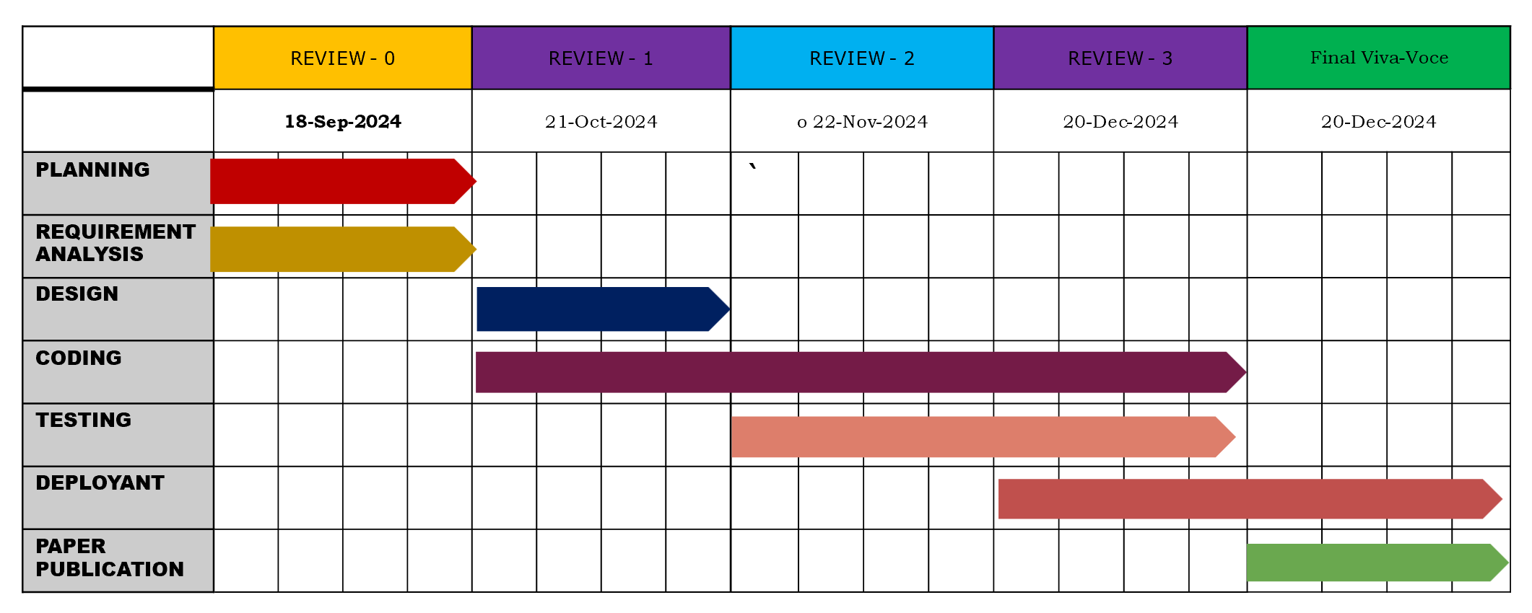
CHAPTER-8
OUTCOMES

- Real-Time Data Access
The application ensures users have access to up-to-date information on hospital services, including bed availability, doctor schedules, and other critical resources. This transparency builds trust in the accuracy of the data and enables users to make informed decisions during emergencies or routine healthcare needs. Real-time updates reduce the frustration of visiting hospitals only to find unavailable services, ensuring a smoother healthcare experience.
- User-Friendly Experience
The app is designed with a simple and intuitive interface, making it easy for users of all technical backgrounds to navigate. Key features like searching for hospitals, booking services, or accessing health articles are presented clearly and logically. A user-friendly design improves satisfaction, encourages repeated use, and ensures accessibility for a wider audience, including older adults or those less familiar with technology.
- Increased Hospital Utilization
By directing patients to the most appropriate hospitals based on their needs, the application optimizes the use of hospital resources. It ensures that patients are distributed more evenly across facilities, reducing overcrowding in specific hospitals while ensuring others are fully utilized. This contributes to better healthcare delivery, minimizes waiting times, and improves overall efficiency in the healthcare system.
- Integration with Emergency Services
Planned future updates aim to integrate the app with local emergency services, allowing users to directly connect with ambulance services, fire departments, or other critical response units. This feature can significantly improve response times in emergencies by reducing communication delays. Users will also receive accurate guidance on the nearest and most equipped emergency facilities, potentially saving lives during critical situations.

CHAPTER-9
RESULTS AND DISCUSSIONS
The Hospital Finder Application successfully delivers an integrated platform that enhances healthcare accessibility and management. It enables users to find hospitals, book lab tests, order medicines, and access health-related information efficiently. The real-time data updates and user-friendly interface improve user trust and satisfaction. Additionally, it contributes to better resource utilization by hospitals and ensures secure management of sensitive user data.

Results

Improved Access to Healthcare Services

The Hospital Finder Application breaks down physical barriers to healthcare by providing users with the ability to find hospitals, book lab tests, and purchase medicines online, regardless of their location. It enables users to access critical healthcare services 24/7 from the comfort of their homes, which is especially important for individuals in remote areas or those with mobility issues. This feature ensures timely access to healthcare without the need to travel long distances or navigate through busy healthcare systems, reducing delays in receiving medical attention.

Enhanced Patient Experience

One of the key features of the application is its intuitive and easy-to-use interface, which ensures that users can navigate through the app without difficulty. Whether they are searching for the nearest hospital, scheduling a lab test, or ordering medicine, the streamlined design allows for a smooth, user-friendly experience. This not only improves overall satisfaction but also encourages consistent use, as users are more likely to return to a platform that is simple, responsive, and tailored to their needs.

Optimized Resource Utilization

By providing real-time updates on hospital bed availability, medical staff capacity, and the status of other resources, the application helps to ensure a more balanced distribution of patients across available healthcare facilities. This reduces the chances of overcrowding in specific hospitals, which can result in longer wait times and strain on medical resources. Additionally, it helps hospitals manage their capacity effectively, ensuring that patients are sent to the most appropriate facility based on their needs, thereby improving overall healthcare efficiency.

Faster Emergency Response

In future updates, integrating the application with local emergency services can significantly improve response times during medical emergencies. Users can quickly connect with ambulance services, fire departments, or other emergency responders directly from the app. This immediate connection reduces delays in emergency care and ensures that help arrives faster. Furthermore, the app can guide users to the nearest available emergency facilities, ensuring that they are directed to the most suitable and equipped hospital for immediate care, potentially saving lives.

Data-Driven Decision Making

The Hospital Finder Application can generate valuable insights from the data it collects, such as user behavior, hospital utilization patterns, and demand for specific services. These insights can be used by healthcare administrators to optimize hospital operations, improve service delivery, and forecast future needs. Hospitals can use this data to allocate resources more effectively, plan for peak demand times, and ensure that essential services are always available. Additionally, it helps healthcare providers make more informed decisions about patient care, improving the quality of healthcare services overall.

Increased Trust and Transparency

Providing real-time, accurate, and up-to-date information about hospital services, including bed availability, doctor schedules, and emergency room statuses, fosters transparency in the healthcare system. Users can make informed decisions about where to seek treatment based on this data, reducing uncertainty and frustration. The trust built through transparency is vital for encouraging users to rely on the app for all their healthcare needs, ultimately creating a more open and reliable healthcare environment. With accurate information at their fingertips, users feel more confident in their decisions, leading to higher satisfaction and better healthcare outcomes.

Discussion

Impact on Healthcare Accessibility

This discussion can explore how the app bridges the gap for people in remote or rural areas who have limited access to healthcare facilities. By offering online services like lab test bookings, medicine orders, and hospital searches, the app makes healthcare more accessible without requiring physical visits.

User Experience and Engagement

Discussion can focus on the design and usability of the app, such as its intuitive interface, easy navigation, and features that cater to all age groups, including elderly users who might not be tech-savvy. The effectiveness of the interface and how it drives user engagement and satisfaction can be explored.

Real-Time Data and Resource Management

The discussion can highlight how real-time data on hospital bed availability and resource status helps hospitals manage capacity efficiently. This would cover how reducing overcrowding, optimizing resource use, and improving patient distribution lead to better care and outcomes.

Integration with Emergency Services

discussion can focus on how integrating emergency services into the app could improve response times in critical situations. The challenges of such integration, including coordination with local emergency teams, data privacy concerns, and technical difficulties, can also be addressed.

Data Privacy and Security

privacy is a critical concern for any healthcare application. This discussion can explore the measures the app takes to protect personal health data, such as encryption, secure login, and compliance with data protection laws like HIPAA (in the U.S.) or GDPR (in Europe). The potential risks of data breaches and solutions to mitigate them can also be part of this discussion.

Scalability and Future Enhancements

This could explore future updates, such as telemedicine integration, AI-driven health advice, or connecting with national healthcare systems. It could also touch on how the app could evolve to include more personalized features, like health tracking or integration with wearable health devices.

Cost-Effectiveness and Affordability

A discussion can revolve around the financial aspect, such as whether the app helps users save money by reducing unnecessary hospital visits or improving the efficiency of healthcare providers, potentially reducing operational costs.

User Feedback and Continuous Improvement

Discuss how user reviews, suggestions, and usage data can be used to enhance the app's functionality. Regular updates based on user feedback can ensure that the app continues to meet the evolving needs of patients and healthcare providers.

CHAPTER-10
CONCLUSION

The proposed Hospital Finder Application represents a crucial advancement in improving healthcare access, particularly during medical emergencies. By providing real-time information on hospital services, available beds, and medical specialists, the app ensures that users can make informed decisions quickly. In high-pressure situations, where every second counts, this feature allows individuals to choose the most appropriate facility or treatment without wasting precious time. This real-time access to critical information can be life-saving, especially when quick decisions are required in emergency care scenarios.
One of the key strengths of the app is its user-friendly interface. Recognizing the stress and urgency that often accompanies medical emergencies, the design of the app prioritizes simplicity and ease of use. Even in moments of high anxiety, users can navigate the app effortlessly, ensuring they can quickly find the help they need. This ease of use is particularly important when patients or their families are in a panic, as it helps reduce confusion and streamline the process of accessing healthcare services.
Moreover, the potential for integrating valuable data analytics is another significant advantage of the app. By gathering and analyzing data on hospital resource utilization, user behavior, and emergency patterns, the app can offer insights that improve overall healthcare efficiency. These insights can help hospitals optimize resource management, enhance patient care, and predict future demand for services. In the long term, data-driven improvements will contribute to better healthcare delivery, ensuring that resources are allocated effectively to meet patient needs.
Ultimately, the Hospital Finder Application has the potential to greatly enhance the overall efficiency of the healthcare system. By combining real-time information, ease of access, and the ability to gather and analyze data, the app not only improves healthcare access for individuals in emergencies but also contributes to the optimization of healthcare operations. This can lead to better outcomes for patients and a more responsive healthcare system overall.

REFERENCES

[1]. Arvind Mehta, Evaluating the Impact of E-Health Systems on Emergency Medical Services in India.Journal of Public Health Research, Volume 15, Issue 3, September 2021, Pages 15-22.
https://jphr.com
[2]. Anjali Bhatt, The Role of Mobile Health Applications in Streamlining Emergency Medical Services in India.Journal of Health Technology, Volume 9, Issue 6, June 2022, Pages 35-42.
https://jht.org
[3]. Shruti Desai, Optimization of Hospital Selection Algorithms for Emergency Medical Care in Urban India.Journal of Applied Algorithms and Computation, Volume 10, Issue 4, November 2020, Pages 47-54.
https://jaac.org
[4]. Amit Kumar, Emergency Health Care Services in India: A Strategic Approach.
International Journal for Multidisciplinary Research, Volume 6, Issue 1, January-February 2024, Pages 5-10.
https://www.ijfmr.com
[5]. Kartik Mishra, Mobile Health Apps and the Future of Emergency Medical Care in India.
Journal of Mobile Technology in Healthcare, Volume 3, Issue 7, July 2020, Pages 21-28.
https://www.jmthc.com
[6]. Naveen Sharma, Emergency Response Systems in India: Leveraging Mobile Applications for Faster Access to Healthcare. Journal of Emergency Medical Services, Volume 7, Issue 3, July 2021, Pages 33-40.
https://jems.com

APPENDIX-A
PSUEDOCODE
<!DOCTYPE html>
<html lang="en">
<head>
<meta charset="UTF-8">
<meta name="viewport" content="width=device-width, initial-scale=1.0">
<title>Hospital Finder</title>
<style>
body {
font-family: Arial, sans-serif;
margin: 0;
padding: 0;
box-sizing: border-box;
background: linear-gradient(to bottom, #003c57, #007a8c);
color: #ffffff;
}

.header {
display: flex;
justify-content: space-between;
align-items: center;
background-color: #ffffff;
color: #003c57;
padding: 20px;
box-shadow: 0 4px 6px rgba(0, 0, 0, 0.1);
}

.header .logo {
font-size: 1.5rem;
font-weight: bold;
display: flex;
align-items: center;
}

.header .logo img {
height: 30px;
margin-right: 10px;
}

.header nav {
display: flex;
gap: 20px;
}

.main {
display: flex;
flex-direction: column;
align-items: center;
text-align: center;
padding: 50px 20px;
}

.main h1 {
font-size: 2rem;
margin-bottom: 20px;
}

.main .search-box {
margin: 20px 0;
width: 100%;
max-width: 600px;
}

.main input {
width: 100%;
padding: 10px;
border-radius: 5px;
border: none;
font-size: 1rem;
}

.features {
display: flex;
justify-content: center;
flex-wrap: wrap;
gap: 20px;
margin-top: 40px;
}

.feature {
background: #ffffff;
color: #003c57;
border-radius: 8px;
padding: 20px;
width: 250px;
box-shadow: 0 4px 6px rgba(0, 0, 0, 0.1);
text-align: center;
}

.feature img {
height: 50px;
margin-bottom: 15px;
}

.feature h3 {
margin: 10px 0;
}

.main .image {
margin-top: 30px;
}

.main .image img {
width: 100%;
max-width: 500px;
border-radius: 10px;
}
</style>
</head>
<body>
<header class="header">
<div class="logo">
<img src="icon.png" alt="Logo">
<span>Hospital Finder</span>
</div>
<nav>
<span>Location Name</span>
<span>Specialty</span>
</nav>
</header>

<main class="main">
<h1>Find the best hospital near you...</h1>
<div class="search-box">
<input type="text" placeholder="Enter your Location or City">
</div>

<section class="features">
<div class="feature">
<img src="hospital-icon.png" alt="Hospital Icon">
<h3>Find nearest hospital</h3>
<p>Search for the nearest medical centres by entering your location or city name.</p>
</div>
<div class="feature">
<img src="directions-icon.png" alt="Directions Icon">
<h3>Get directions</h3>
<p>Click on the map to get the route to the hospital of your choice.</p>
</div>
<div class="feature">
<img src="review-icon.png" alt="Review Icon">
<h3>Review services</h3>
<p>Leave a review of the services provided at your selected medical centre.</p>
</div>
</section>

<div class="image">
<img src="doctor.png" alt="Doctor">
</div>
</main>
</body>
</html>

APPENDIX-B
SCREENSHOTS
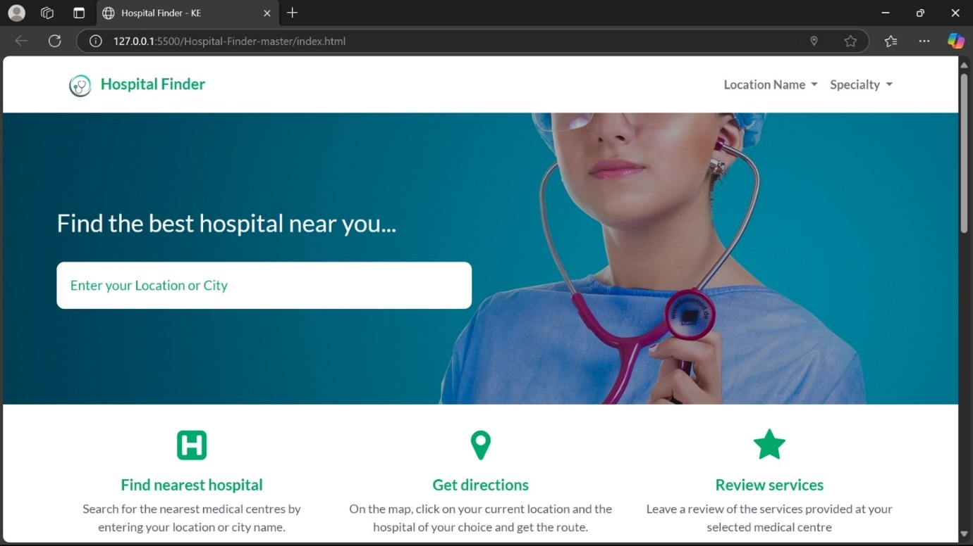

Fig.1.Home Page

This is the home page of a "Hospital Finder" web application designed to help users locate and select the best hospitals near them.

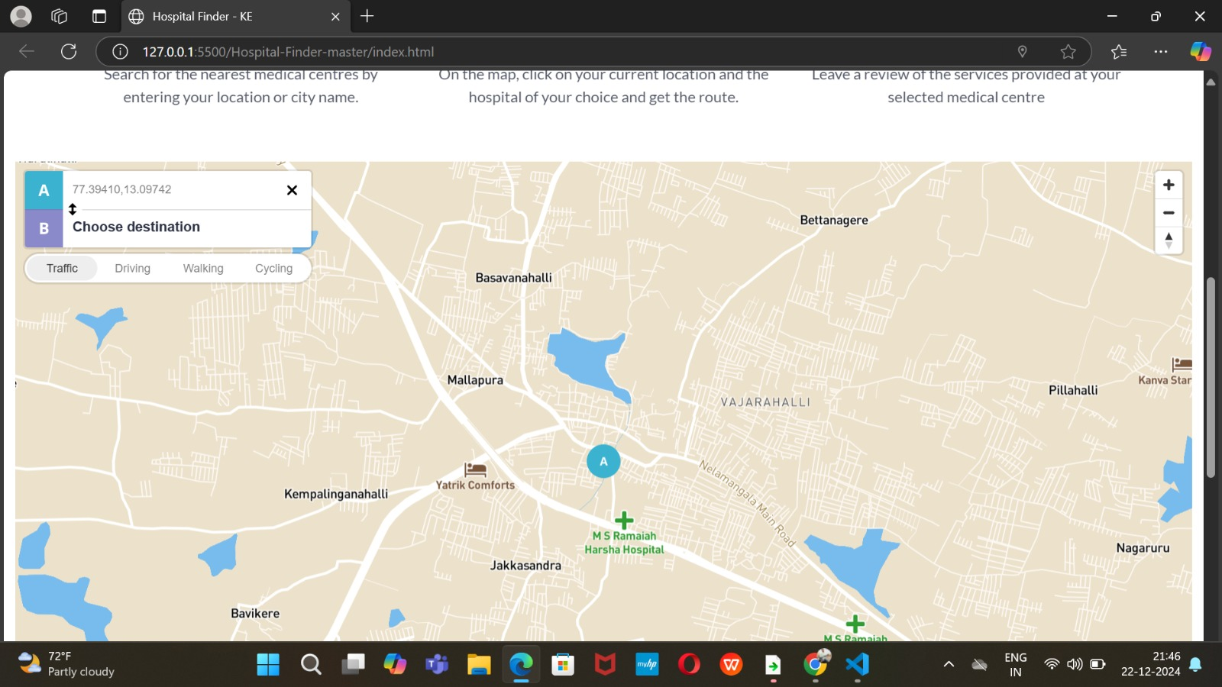

.

Fig.12.Hosiptal List Page

The Hospital Details Page provides a complete overview of the selected hospital, enabling users to access vital information seamlessly. This page includes key details such as the hospital name, location, specialties, contact information, and available facilities. Users can also view the hospital ratings, reviews, consultation hours, and emergency services. The page typically offers options to book appointments, navigate to the hospital location, or contact hospital representatives directly. Additionally, users may explore specific departments, doctors' profiles, and available treatments for better decision.

APPENDIX-C
ENCLOSURES
Sustainable Development Goals:

Sustainable development goals of hospital finder: Explanation: Creating a web app focused on hospital finder aligns with several Sustainable Development Goals (SDGs). However, it's important to note that directly copying or paraphrasing content without proper citation is considered plagiarism. Here's a list of potential SDGs related to a hospital finder web app, along with brief explanations to help you develop your content while avoiding plagiarism.

Good Health and Well-being (SDG 3): Explanation: The primary goal of a hospital finder app is to contribute to improving access to healthcare services, ensuring good health and well-being for individuals.

Industry, Innovation, and Infrastructure (SDG 9):
Explanation: Developing a technology-based solution like a hospital finder app involves innovation in healthcare infrastructure, contributing to sustainable development.

Reduced Inequality (SDG 10): Explanation: By facilitating equal access to healthcare services through the app, you can contribute to reducing inequalities in health outcomes across different socio-economic groups.

Partnerships for the Goals (SDG 17): Explanation: Collaborating with healthcare providers, governmental bodies, and NGOs is crucial for the success of the hospital finder app, promoting partnerships to achieve sustainable development goals.

Life on Land (SDG 15):
Explanation: Ensuring access to healthcare services, especially in rural or remote areas, contributes to sustainable development by promoting the well-being of communities and the ecosystems they are part of.

Responsible Consumption and Production (SDG 12):
Explanation: Developing a hospital finder app involves considering sustainable practices in software development, contributing to responsible consumption and production. When incorporating these SDGs into your content, make sure to express the ideas in your own words and provide proper citations if you use specific information or statistics. This helps you avoid plagiarism and ensures the content is original and accurate.

GITHUB link; https://github.com/Mahesh-219/hopsitalfinder

